Welcome to Germany!
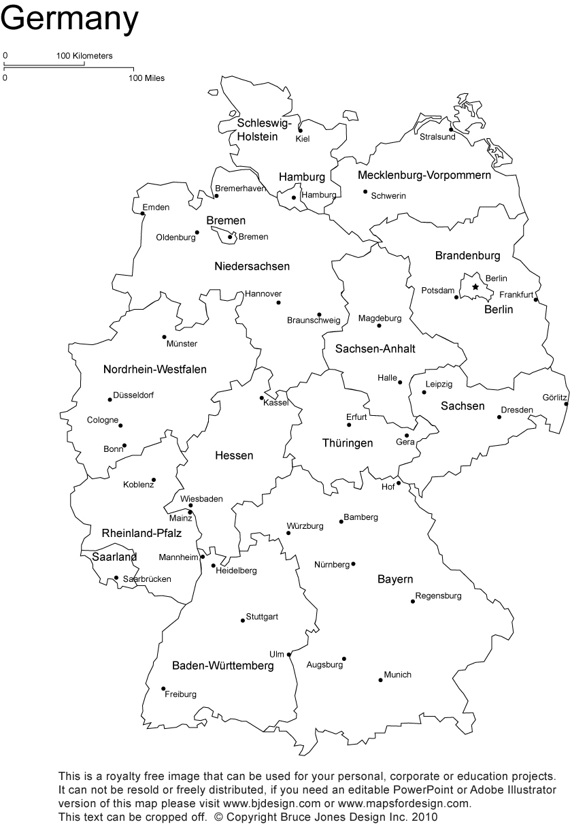

First Step: Travel to Germany!
Who will travel with you?

Pick a City:
- Berlin
- Dresden
- Hamburg
- Heidelburg
- München
How will we get there?
- Airplane
- Boat
- Train
- Car

Second Step: Apply to Asylum!
Asylum is a right that is protected by the Constitution in Germany. People who are displaced from other parts of the world, fleeing from violence, war and terror, are to find protection in Germany.
This process is very long and difficult, but if you get approved, you have the rights and protections of a German citizen.

Third Step: Find a Place to Live
- Apartment 1: 4 rooms, kitchen, bathroom, 103 m². $740.
- Apartment 2: 3 rooms, kitchen, bathroom, balcony, 82 m². $630
- Apartment 3: 1 room, kitchen, bathroom, 35 m². $250
- Apartment 4: 2 rooms, bathroom, 86 m². $585.
- Apartment 5: 1 room, furnished, bathroom, 19 m². $230

Fourth Step: Learn German!
Hallo- Hello
Guten Tag- Good day
Mein Name ist…- My name is….
Was ist dein Name?- What is your name?
Ich komme aus…- I am from…
Woher kommst du?- Where are you from?
Ich spreche....- I speak
Frau- Mrs.
Herr- Mr.

Guten Tag Herr/Frau _____________.
Mein Name ist _________________.
Ich spreche Englisch.
Ich Komme aus _________________.
Woher kommst du?
Fifth Step: Find a Job!
- Cook
- Secretary
- Taxi Driver
- Waiter
- Electrician
- Accountant
- Hotel manager
- Car mechanic
- Salesperson

